Project 2 Report

The files included are “game.c”, “gameLog(1-5).txt”, “README”, and this file. The “game.c” file contains my program for the “Matching Cards” game described in project instructions. The “gameLog’x’.txt” files represent the game log of 6 rounds of the card game with ‘x’ representing the seed used for that run. The “README” file describes how “game.c” is compiled and run on the school servers. This file will describe what “game.c” does and the results it produced.

ASSUMPTIONS: My output is based on the example output shown in the instructions, which seemed to exclude the dealer’s actions except for when the round ends and in the console output. I also had it show the target card each time it compared it to the player’s hand as that is what the example output appeared to show. The round robin order is dependent on the dealer.

The program “game.c” utilizes pthreads.h to create 6 threads for the 6 players that will be participating in the game. As each thread enters the player function, they are sorted to into a waiting queue until the dealer has shuffled the deck and passed the cards. Then the round begins which outputs the following to console each time a player compares their hands to the target card.

Console Output: 

While this is printed to console, the following is printed to the game’s log file.

File output during a round:

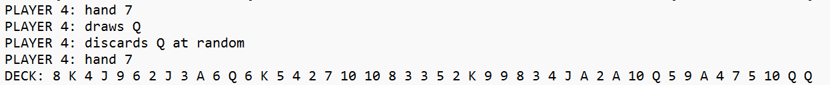

File output at the end of a round:

Each turn after a player has discarded their card and the deck is displayed, they wake up the next process and are put back into the waiting queue until a winner is found. At the end of the round all cards are returned to the deck, then the next dealer is selected, and the queue is then resorted to cycle starting from after the dealer. Then the next round commences until 6 rounds are completed in which all threads exit and join, which completes a run of the game. A thing to note however is that upon repeated testing I noticed that sometimes the results vary slightly in which one player will be placed one before they are supposed to for a round, but it doesn’t seem common.